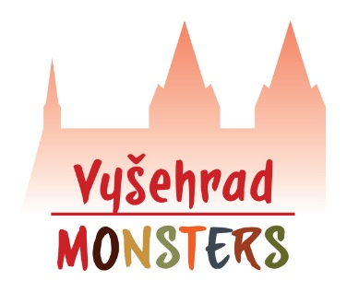
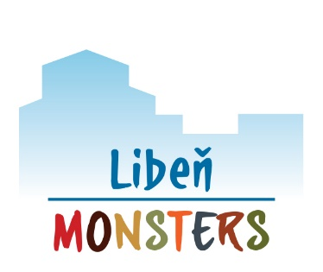

APPLICATION FOR ENROLLMENT
ENGLISH OUTDOOR PRECHOOL

Operator:
All4kids, z.s. (IČ 22771611)
Address: U Libeňského pivovaru 31, 180 00, Praha 8
Account number: 2500191607/2010
Statutory: Barbora Drážníková
www.all4kids.fun

Preschool:
☐ Libeň Monsters (Na Hrázi 11, Praha 8)
☐ Vyšehrad Monsters (Na Pankráci 22, Praha 4)

Type of attendance:
☐ all-day attendance 8:00 – 17:00 (kids under 3 years til 15:30)
☐ full program (whole week)
☐ 4 days a week, please specify: _________________
☐ 3 days a week, please specify: _________________
☐ half-day attendance 8:00 – 12:30 (only for kids under 3 years)
☐ full program (whole week)
☐ 4 days a week, please specify: _________________
☐ 3 days a week, please specify: _________________

Parents (legal representatives):

Name and Surname: __________________________________
Date of birth: __________________________________
Address: __________________________________
Employment: __________________________________
Contact phone: __________________________________
Contact e-mail: __________________________________

Name and Surname: __________________________________
Date of birth: __________________________________
Address: __________________________________
Employment: __________________________________
Contact phone: __________________________________
Contact e-mail: __________________________________

Child’s name and surname: __________________________________
Date and place of birth: __________________________________
Personal ID: __________________________________
Permanent address: __________________________________
Nationality: __________________________________

Application for enrollment of the child for attendance starting from: _________________

Information about the health condition of the child:
☐child is healthy
☐child requires special care in the area (tick and specify):
☐medical: __________________________________
☐sensorial: __________________________________
☐physical: __________________________________
☐dietary: __________________________________
☐other: __________________________________

Other information about the health condition:
allergies: __________________________________
permanent medication: __________________________________
other limitation: __________________________________

Parent claims, that the statement on the health condition of the child, which is a condition for enrolling the child for attendance, contains accurate, truthful and complete information.

Any other cimcurstances you feel important to tell us in relation with enrollment of the child:
____________________________________________________________________________________________________________________________________________________________________________________________________________________________________________________________________________________________________________________________________________________________________________________________________________________________________________________________________________________________________________

In Prague on …………………. ……………………………………… signature of parent / legal representative

