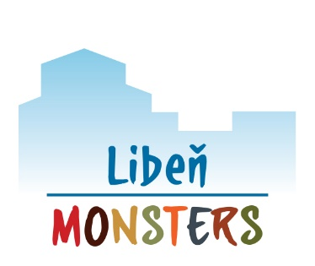
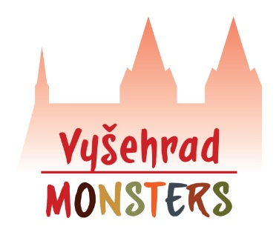

APPLICATION FOR A DAY CAMP
ENGLISH OUTDOOR PRESCHOOL

Operator:
All4kids, z.s. (IČ 22771611)
Address: U Libeňského pivovaru 31, 180 00, Praha 8
Account number: 2500191607/2010

Contact:
info@all4kids.fun; 607 757 816 (Markéta)

Preschool:
☐ Libeň Monsters (www.libenmonsters.cz)
☐ Vyšehrad Monsters (www.vysehradmonsters.cz)

Chosen camp(s):
☐ 8th – 12th July ☐ 5st – 9th August
☐ 15th – 19st July ☐ 12th – 16th August
☐ 22nd – 26th July ☐ 18th – 23rd August
☐ 29th July – 2nd August
(note: program daily 8:30 a.m. – 4:30 p.m.)

Name and Surname of child: _________________________
Date of birth: _________________________
Address: _________________________

Name and Surname of parent: _________________________
Date of birth: _________________________
Permanent address: _________________________
Postal address (if different): _________________________
Contact phone: _________________________
Contact e-mail: _________________________

Information about the health condition of the child (tick):

☐child is healthy
☐child requires special care in the area (tick and specify):
☐medical: _________________________
☐sensorial: _________________________
☐physical: _________________________
☐dietary: _________________________
☐other: _________________________

Other information about child:
allergies: _________________________
permanent medication: _________________________
other limitations: _________________________

Parent claims, that the statement on the health condition of the child, which is a condition for enrolling the child for attendance, contains accurate, truthful and complete information. Furthermore parent declares that before taking the child to day camp, he becomes acquainted with the Code of Operation (published at the website of the preschool), under which the day camp will be realized, in all relevant points. Parent notes that one of the safety conditions of outdoor activities is appropriate clothing, footwear and other equipment suitable for the time of the year and current weather.

The price for one day camp is CZK 3500. Price includes all-day program, meals (snack-lunch-snack), drinks and all utilities. The whole ammont is to be paid until 10 days after confirmation of enrollment, but not later than a week before the day camp starts, via bank trasfer to the bank account of the operator - number 2500191607/2010 (Fio Banka). As a variable symbol, please note the date of birth of the child, the message for the recipient should contain name and surname of the child. The payment is refundable only in case of a substitute to attend the camp. Otherwise, payment is forfeited to the organizer.

Parent mentioned above will bring a pick up the child in person. Please, fill in maximum two other persons to be authorized to bring of pick up the child. The teachers are allowed to check the identity of these persons.

Name and surname: _________________________
Relation to the child: _________________________
Date of birth: _________________________
Permanent address: _________________________
Phone contact: _________________________

Name and surname: _________________________
Relation to the child: _________________________
Date of birth: _________________________
Permanent address: _________________________
Phone contact: _________________________

In Prague on …………………. ……………………………………… signature of parent (legal representative)

Explicit informed consent with the processing of personal data

I, the undersigned, Mr. / Mrs. …………………………………………………
as the legal representative of the child ……………………………………..…,
hereby provide an explicit consent to All4kids, z.s. to process and keep the personal information regarding myself and my child for the purpose of:

- Processing the necessary documentation to ensure the running of the day camp (personal and sensitive information regarding the child – name, surname, date of birth, permanent residence, citizenship, health insurance, information on health and special educational needs; personal data of the child’s legal representatives)
- Organisation of the day camp (contact information of the child’s legal representatives – phone number, e-mail; data of persons to pick up the child).

After the child stops attending the camp, this information will be no longer processed, but will be archived in accordance with the code of archiving and retention for the period of 5 years; after the expiry of this period the information will be duly discarded.

I had been instructed that it is not compulsory to provide the data. I had been also instructed on the following:

- my right to withdraw this consent, even without stating the reason,
- my right to access this information as well as on my right to request correction,
- my right to have this data erased if it is processed in a way contradictory to protection defined by the relevant legislation or in contradiction to this consent, or if the consent is withdrawn.

In Prague on …………….. Signature: ……….………………………..

Consent with processing of personal data by means of photographs, audio/video recordings

I, the undersigned, Mr. / Mrs. …………………………………………………
as the legal representative of the child ……………………………………..…,
hereby provide an explicit consent to All4kids, z.s. to take photographs, video and audio records during my child’s attendance at the day camp, as well as to process the data contained within, for the purpose of:

- Documentation of the club activities or events for the parents
- Publishing these records on the website, social media, and in promotional materials

After the child stops attending the camp, this information will be no longer processed, but will be archived in accordance with the code of archiving and retention for the period of 5 years; after the expiry of this period the information will be duly discarded.

I had been instructed that it is not compulsory to provide the data. I had been also instructed on the following:

- my right to withdraw this consent, even without stating the reason,
- my right to access this information as well as on my right to request correction,
- my right to have this data erased if it is processed in a way contradictory to protection defined by the relevant legislation or in contradiction to this consent, or if the consent is withdrawn.

In Prague on …………………. Signature: ……….………………………..

